VOYAGE ANALYTICS: MLOPS INFRASTRUCTURE & DEPLOYMENT DOCUMENTATION

Author: Sanidhya Shekhar
Project: Voyage Analytics - Integrating MLOps in Travel
Date: June 2026
CHAPTER 1: PROJECT OVERVIEW & ARCHITECTURE
Voyage Analytics is an end-to-end MLOps platform engineered to bring production-ready machine learning solutions to the travel and tourism sector. This framework integrates three core intelligent engines:
Flight Price Prediction: Fully automated via a robust MLOps pipeline covering automated scheduling, continuous integration, containerized scaling, and experiment tracking.
1. REGRESSION MODEL DEVELOPMENT (FLIGHT PRICE PREDICTION)
- Objective: Built a robust regression model using the flights.csv dataset to accurately predict flight prices. The pipeline incorporates strict feature engineering, selection, training validation, and evaluation to ensure maximum model reliability.
2. REST API FOR REGRESSION MODEL (FLASK)
- Objective: Developed a real-time prediction serving layer using a Flask REST API (flight_price_api.py). It exposes web endpoints (such as /predict) to dynamically serve the serialized model artifact.
- System View:
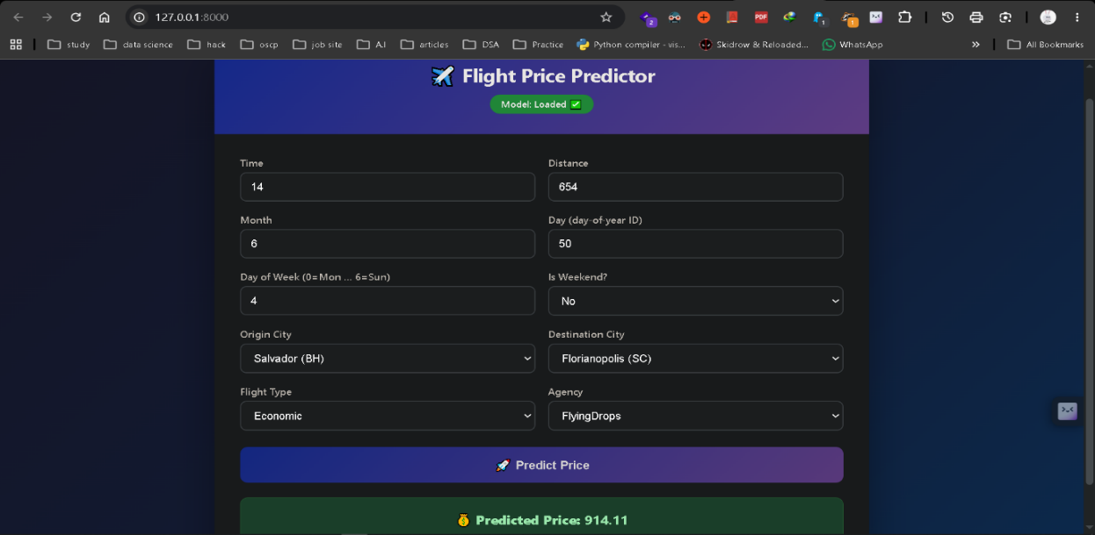
Caption:Active Flask REST API endpoint returning automated, real-time flight price prediction JSON payloads.
3. CONTAINERIZATION (DOCKER)
- Objective: Packaged the flight price prediction application and its dependencies into a Docker container image to ensure environmental portability, isolated execution environments, and flawless deployment across infrastructure targets.
System View:
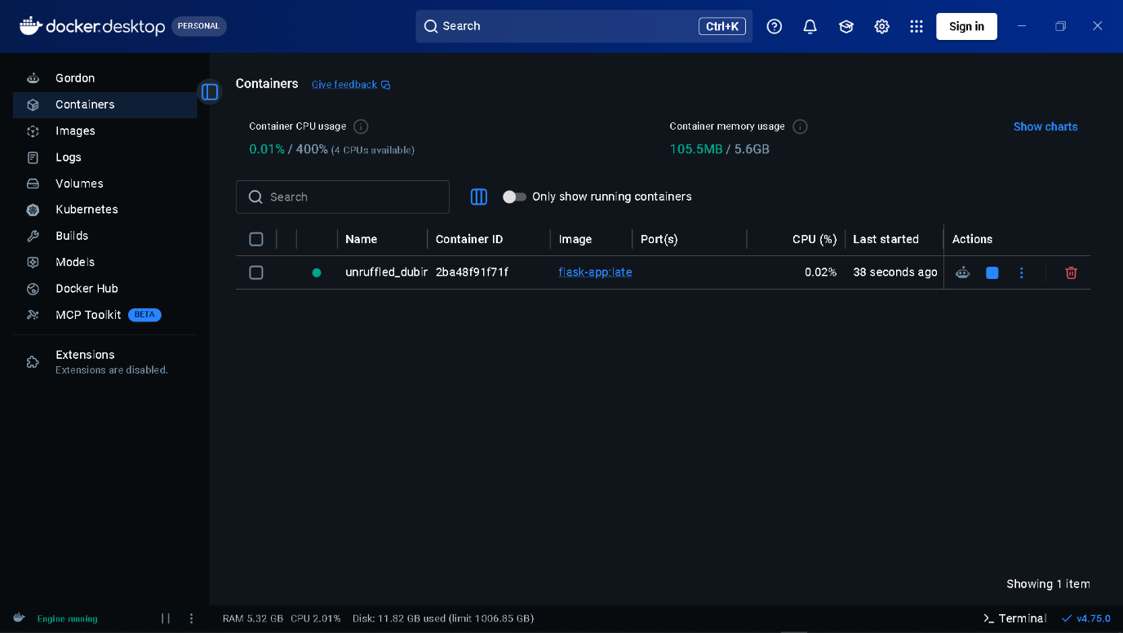

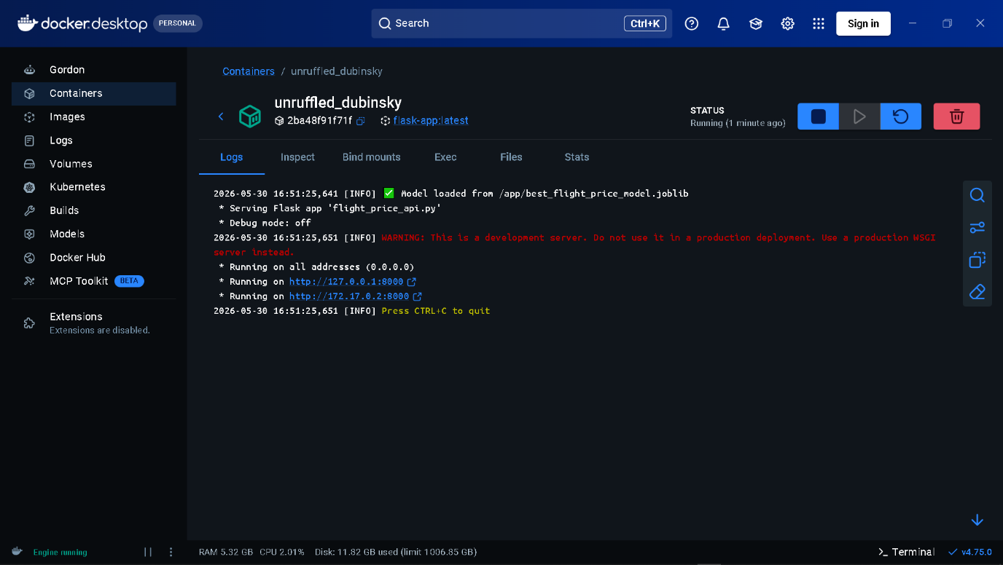
Caption: Dockerized application engine illustrating isolated, lightweight container states for the model environment.

4. KUBERNETES FOR SCALABILITY
- Objective: Orchestrated the containerized flight price API inside a Kubernetes (K8s) cluster using custom manifests (flight-price-deployment.yaml). This manages auto-scaling, load balancing, and ensures high-availability under varying traffic volumes.
- System View:
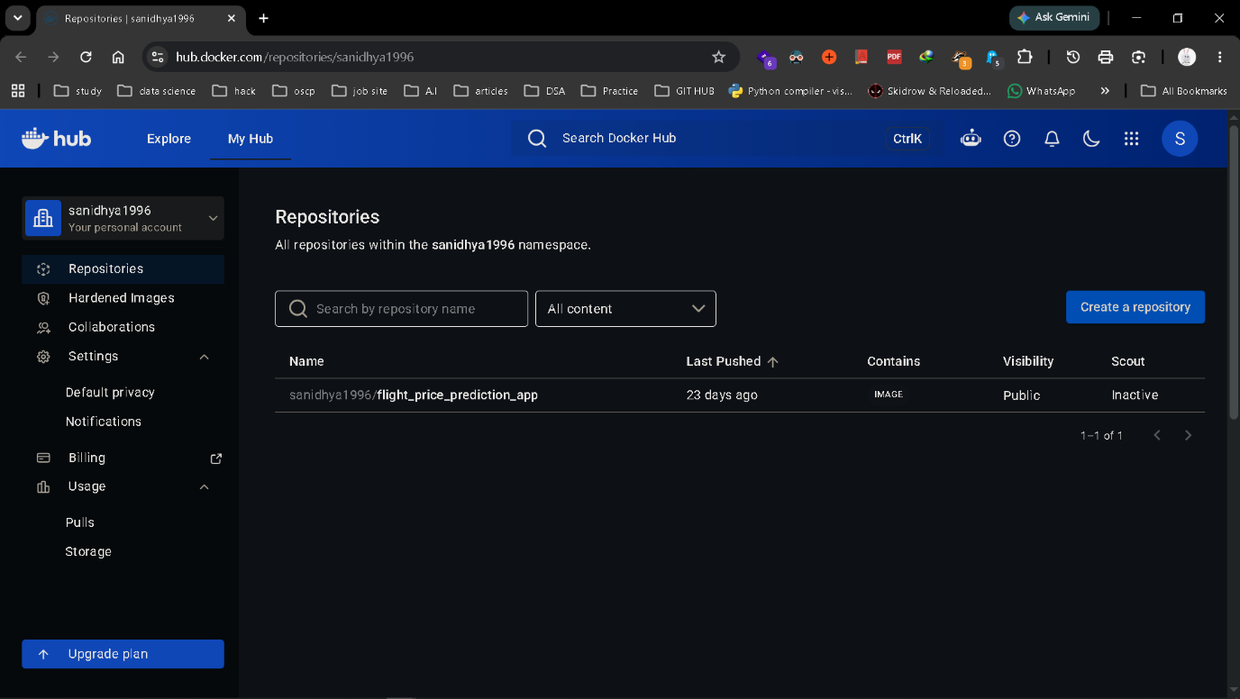
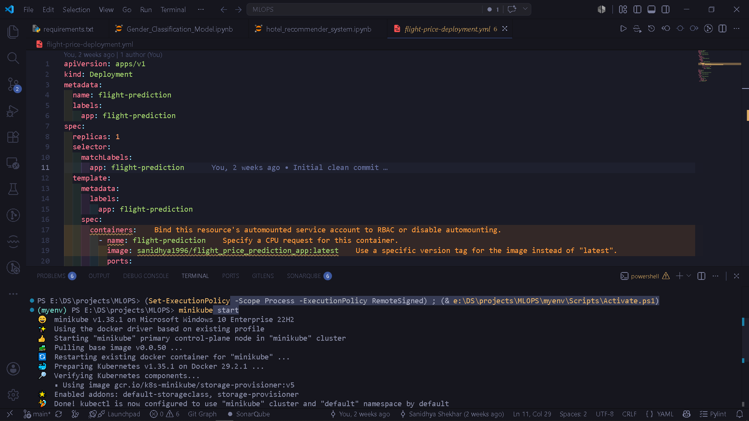
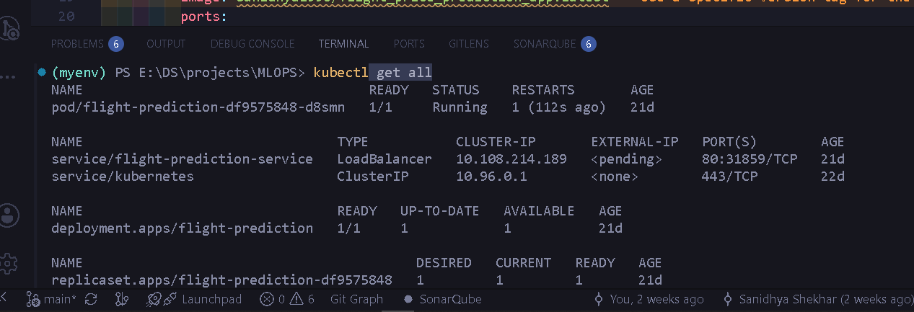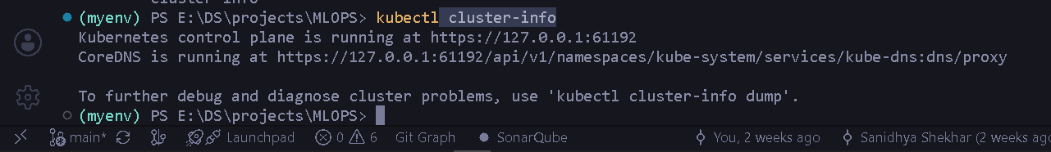
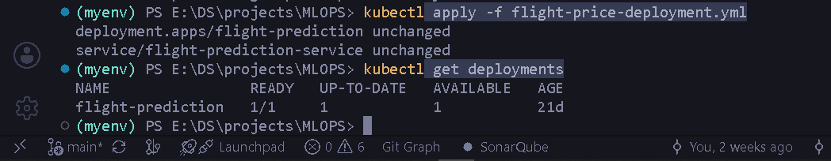
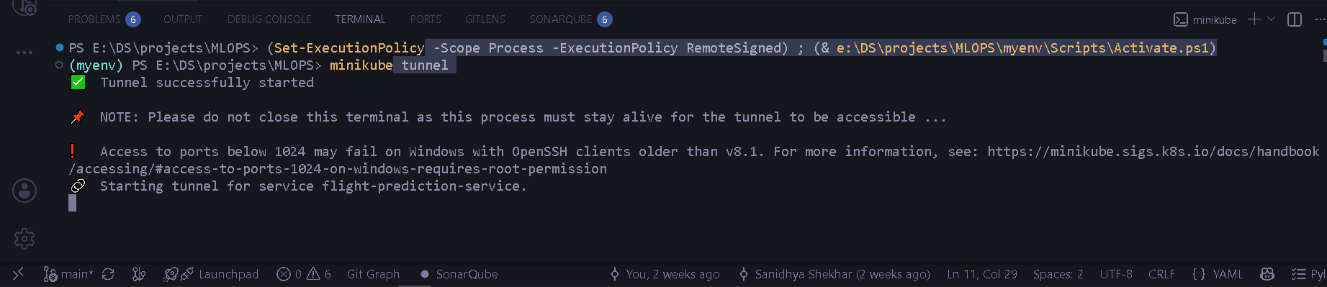
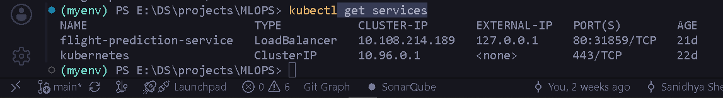
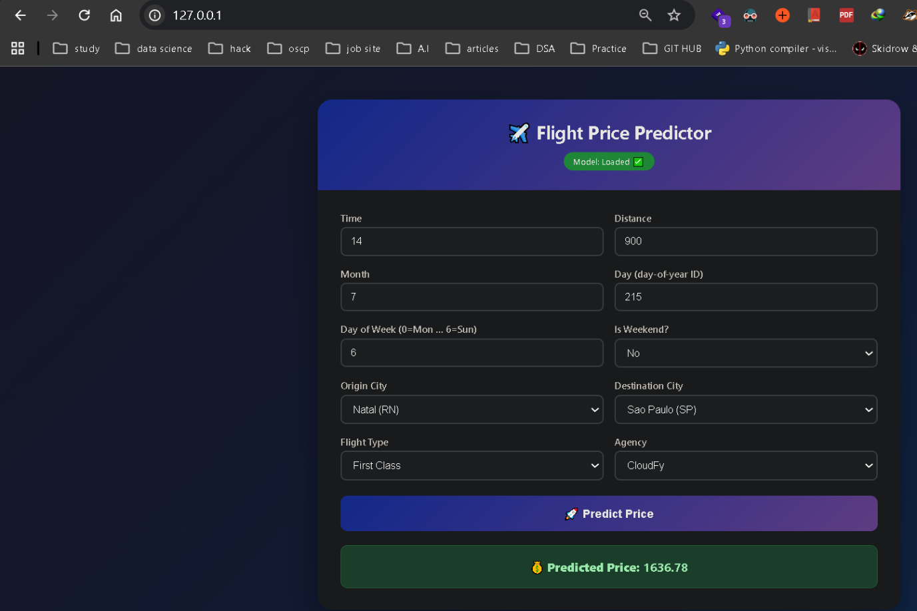
Caption:Kubernetes cluster view displaying active, replicated application pods managing scalability parameters.
5. AUTOMATED WORKFLOWS WITH APACHE AIRFLOW
- Objective: Engineered data orchestration pipelines inside the airflow-docker/ framework. Custom Directed Acyclic Graphs (DAGs) automate periodic data ingestion schedules, automated preprocessing, and model evaluation routines safely.
- System View:
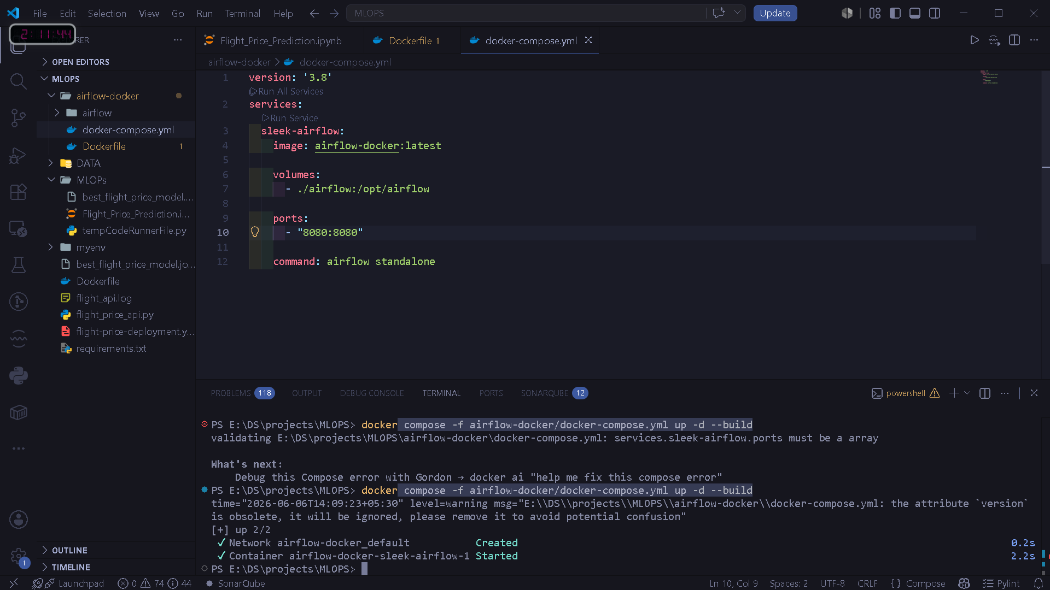
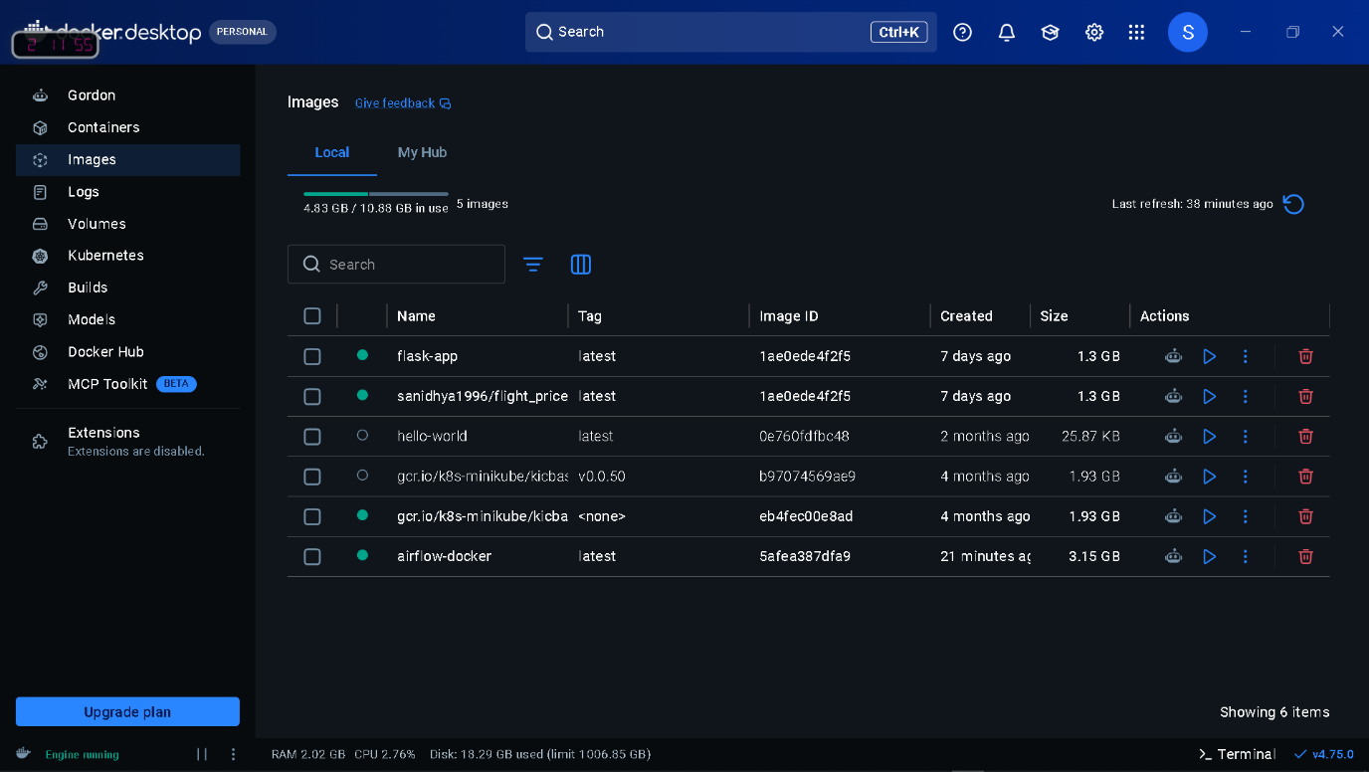
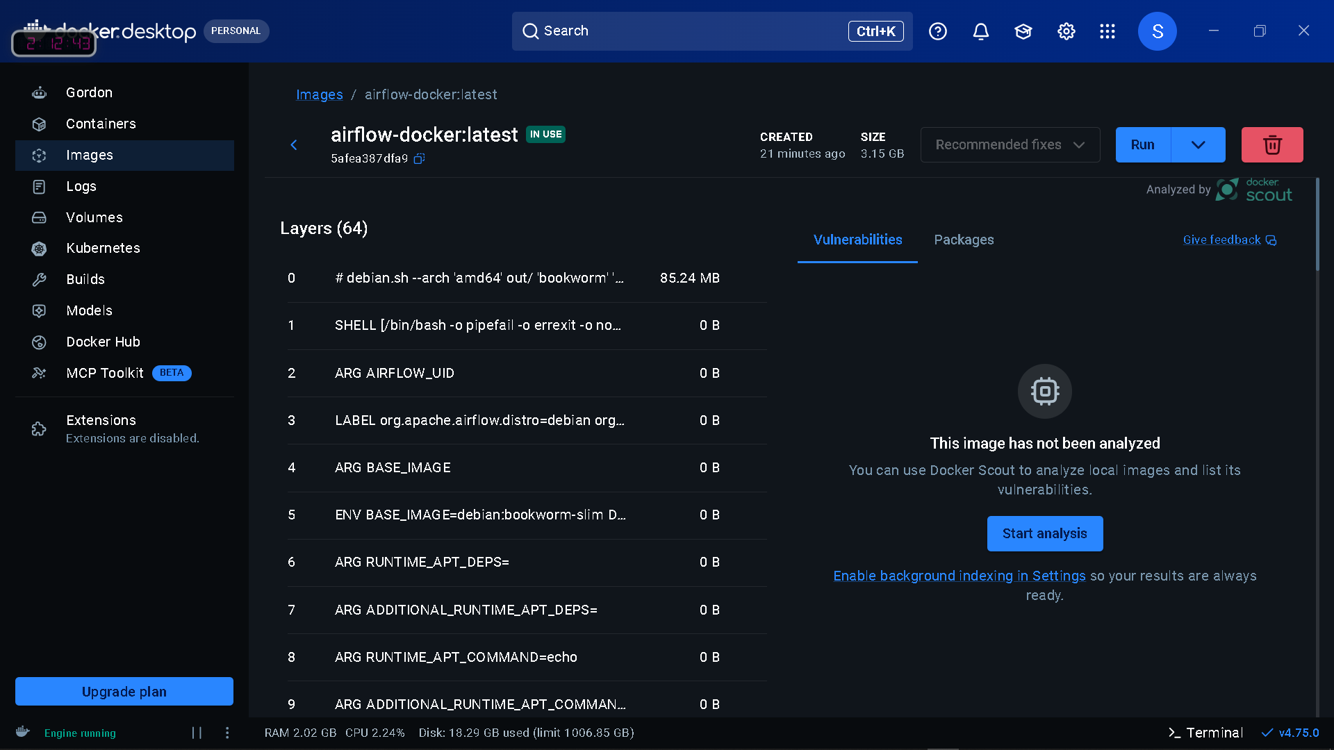
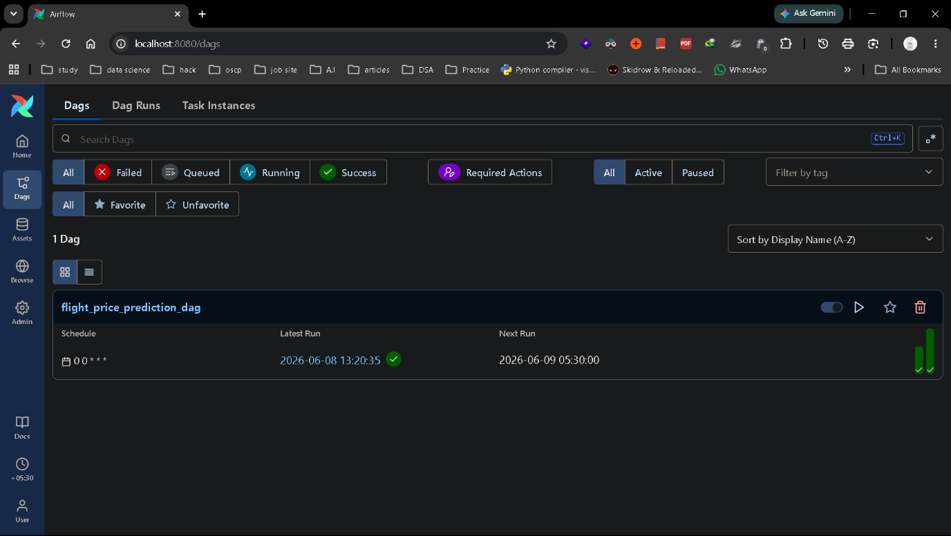

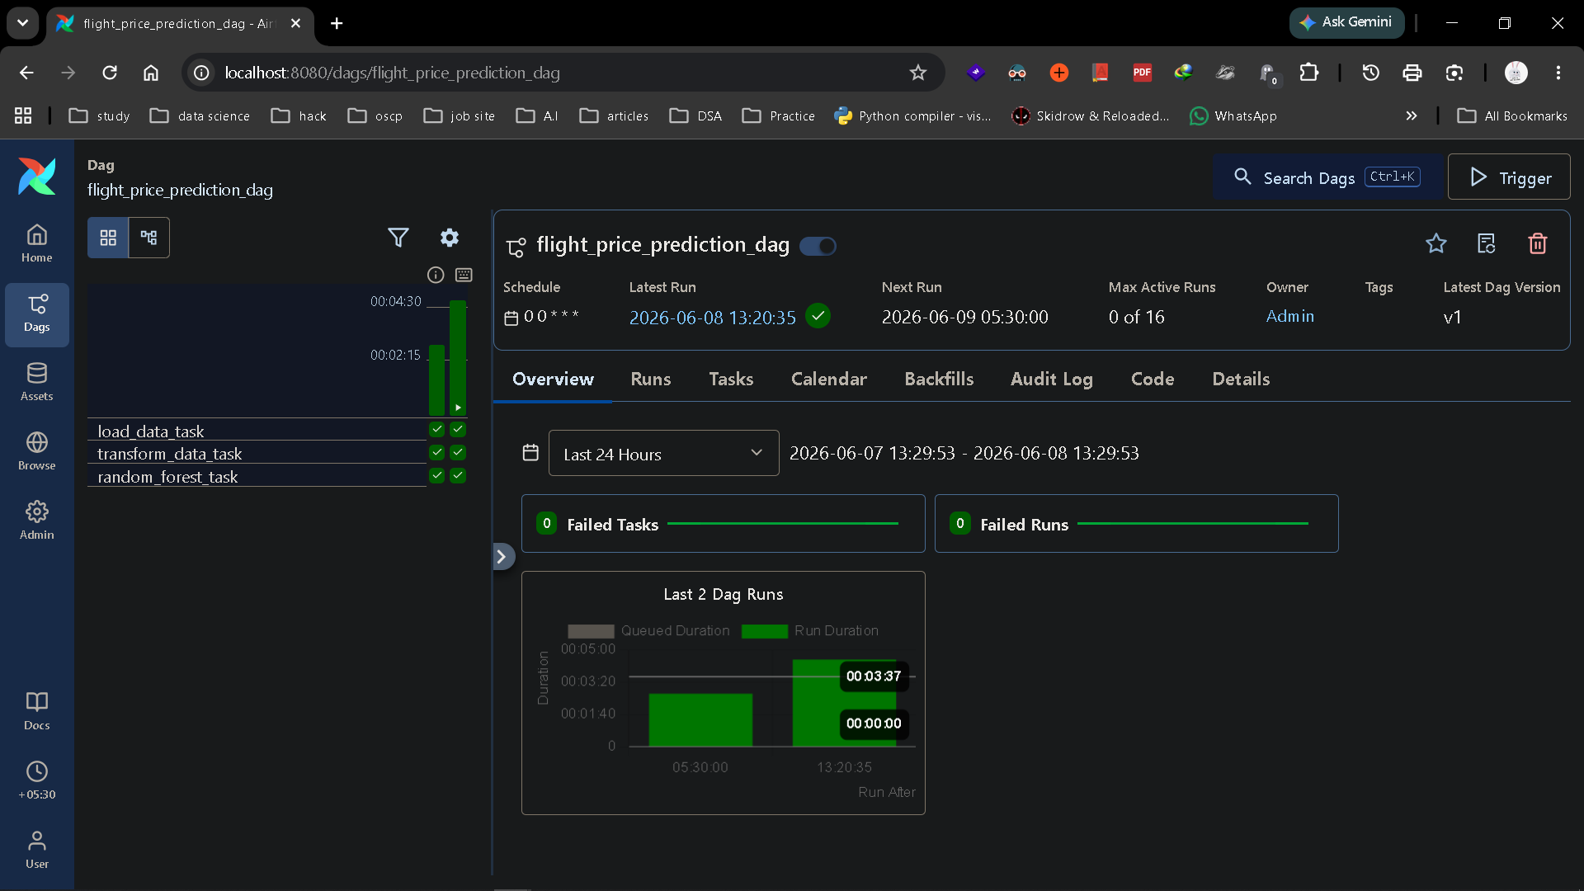
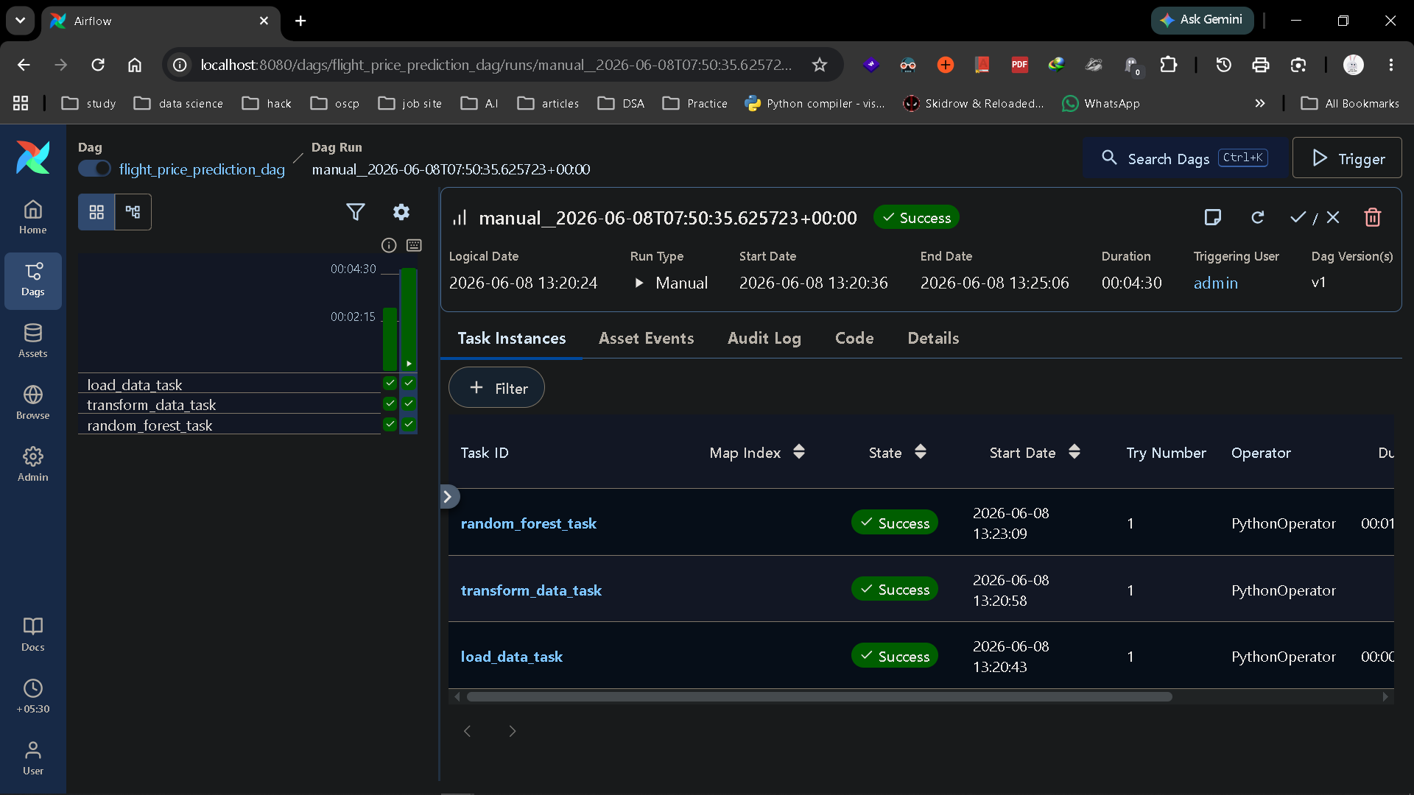

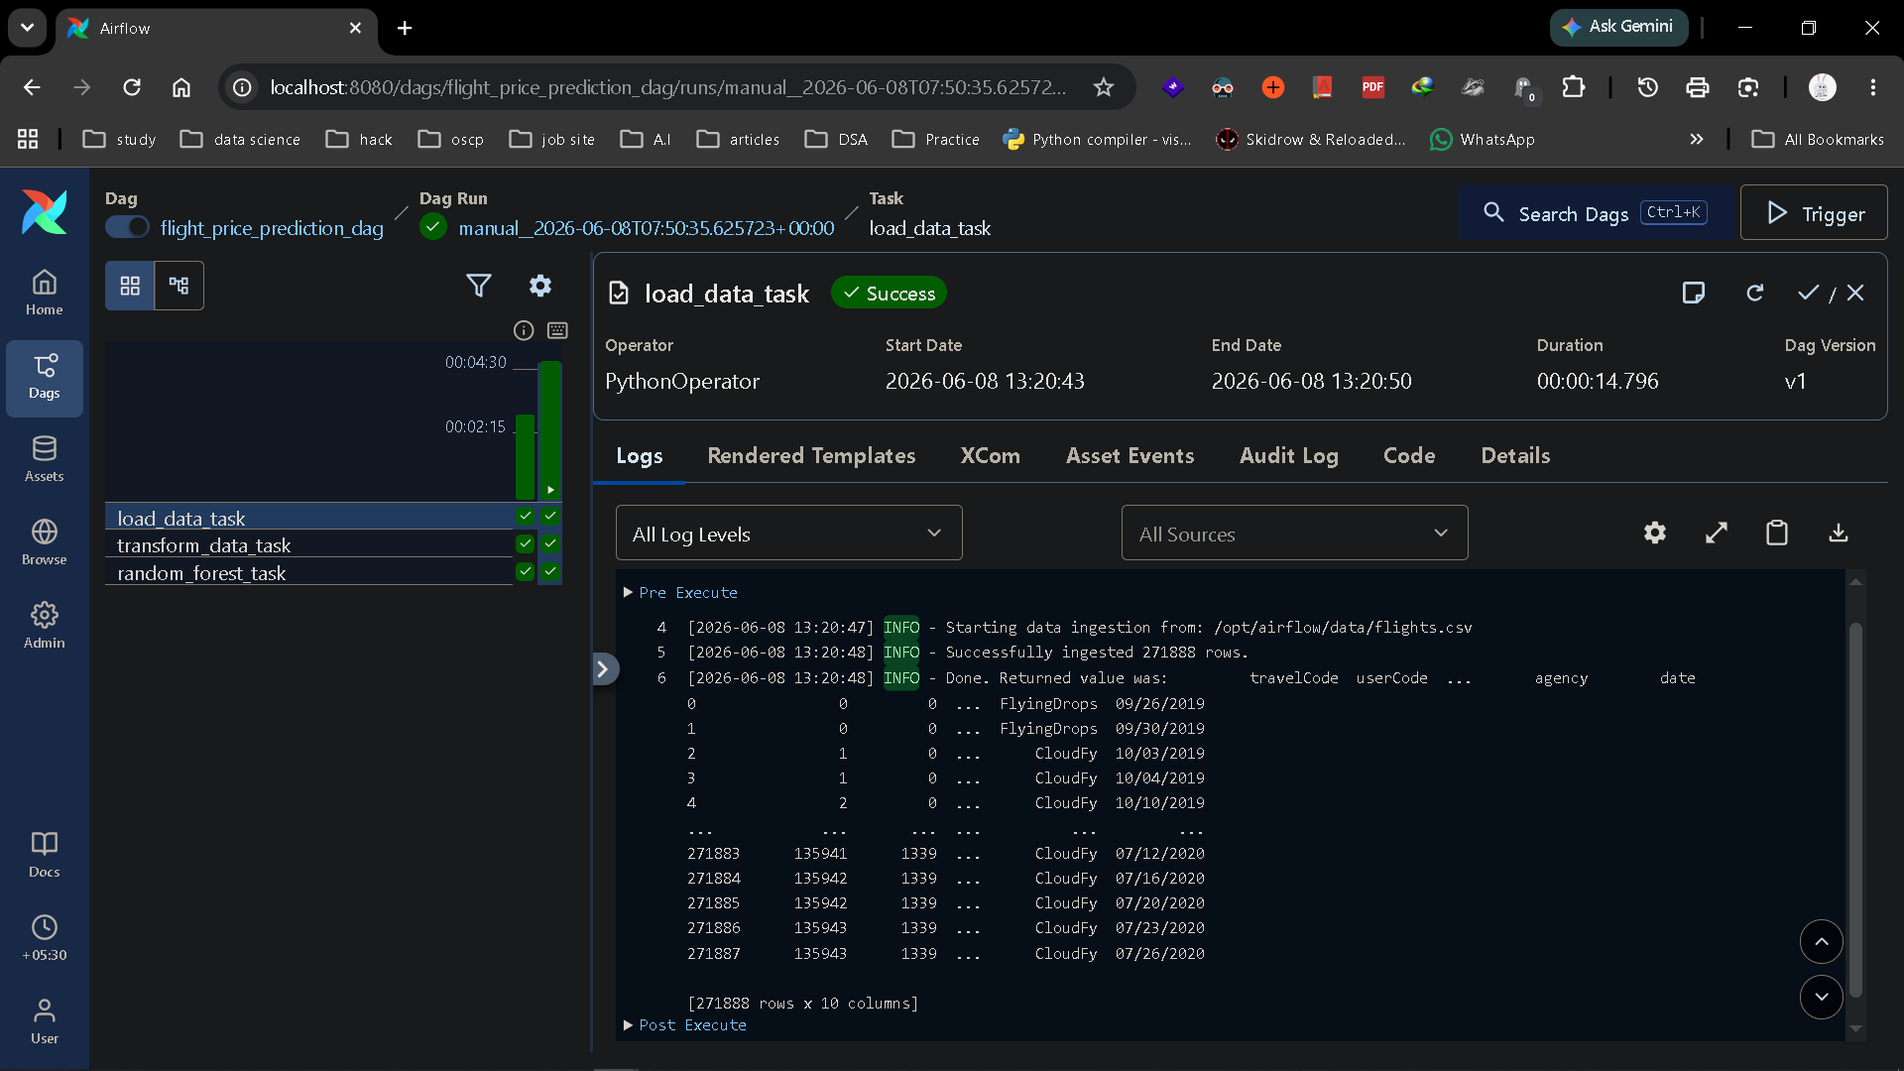
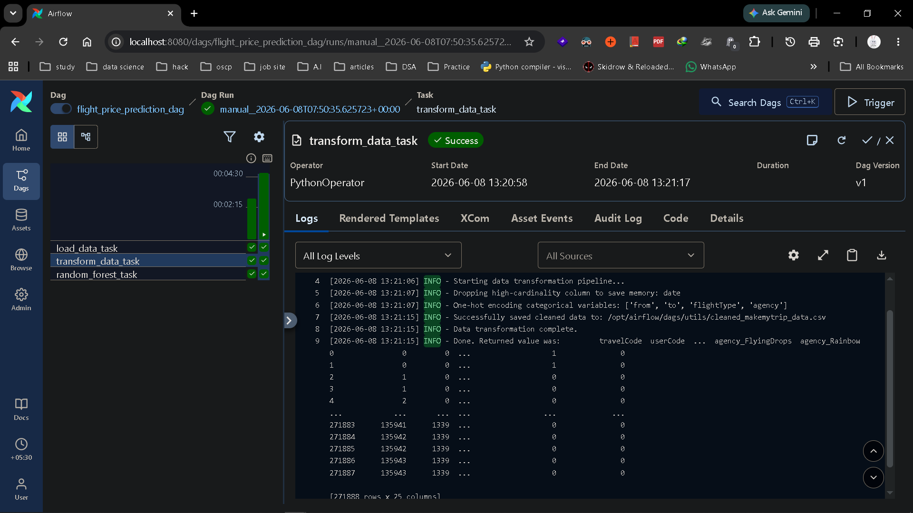

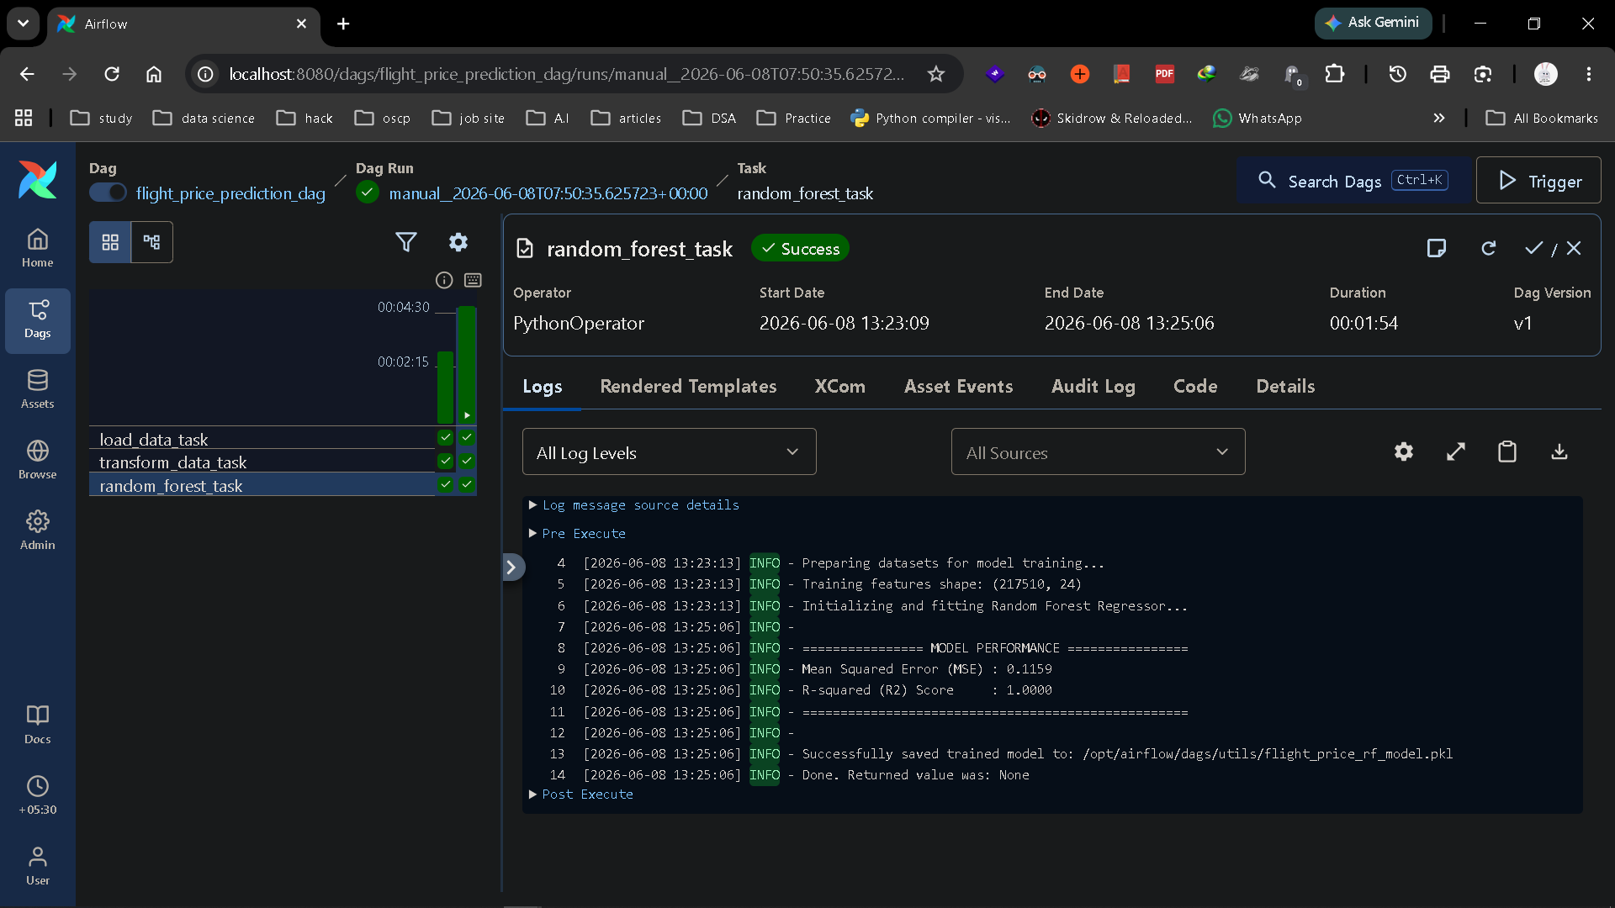
- Caption: Apache Airflow Graph View displaying successful, green-lit execution workflows for automated travel analytics.

6. CI/CD PIPELINE WITH JENKINS
- Objective: Established a Continuous Integration and Continuous Deployment (CI/CD) pipeline inside Jenkins. Code updates triggered via repository changes automatically run tests, rebuild Docker images, and deploy updates with zero downtime.

- System View:
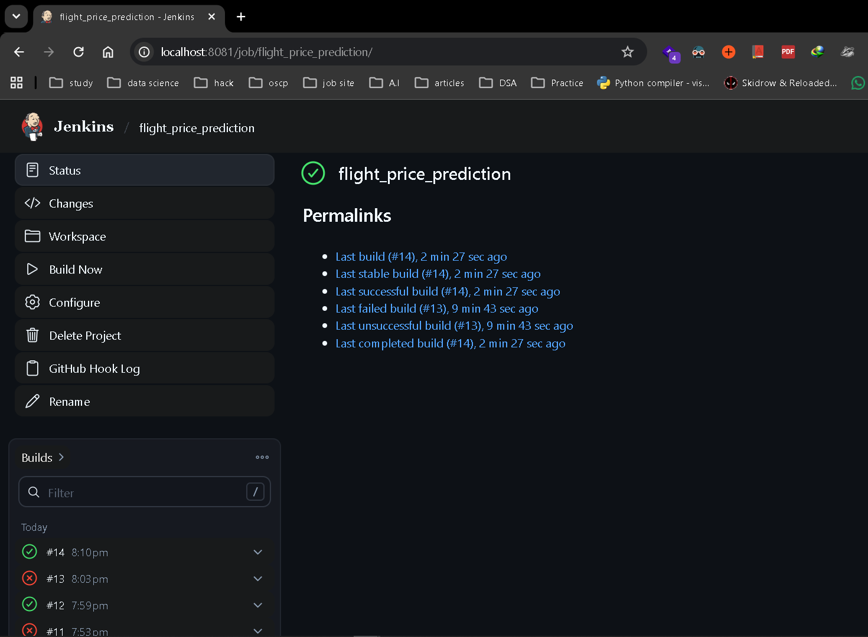
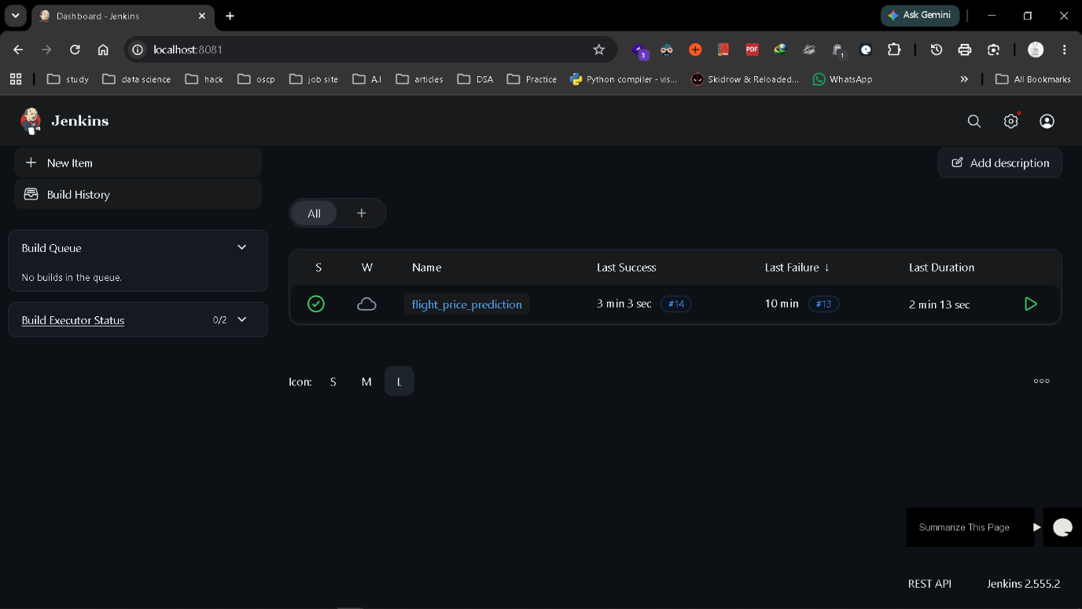
- Caption: Jenkins automation pipeline showcasing a flawless automated build, verification, and deployment execution cycle.

7. MODEL TRACKING WITH MLFLOW
- Objective: Integrated MLflow for enterprise-grade experiment tracking and versioning. The setup tracks running hyperparameters, performance logs, evaluation charts, and records production-ready models within the centralized model registry.
- System View:
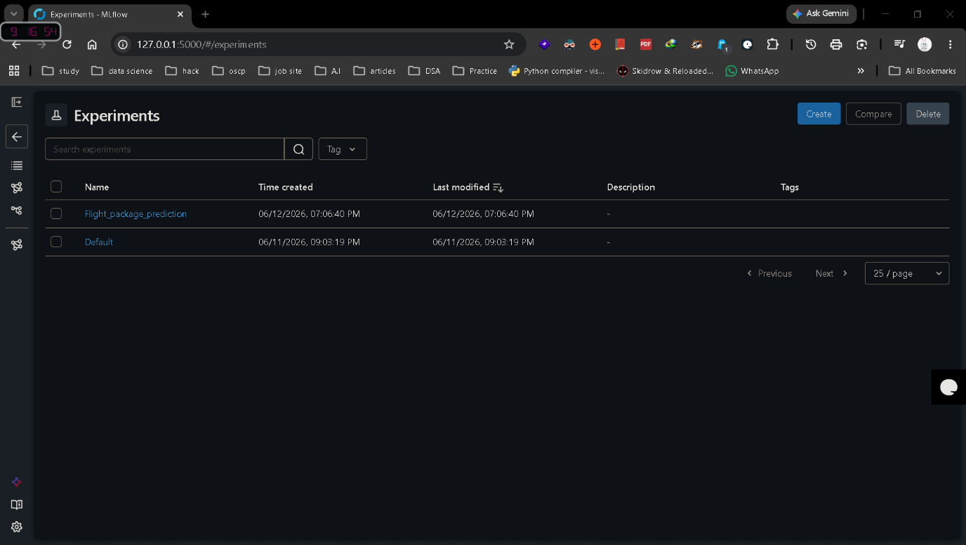

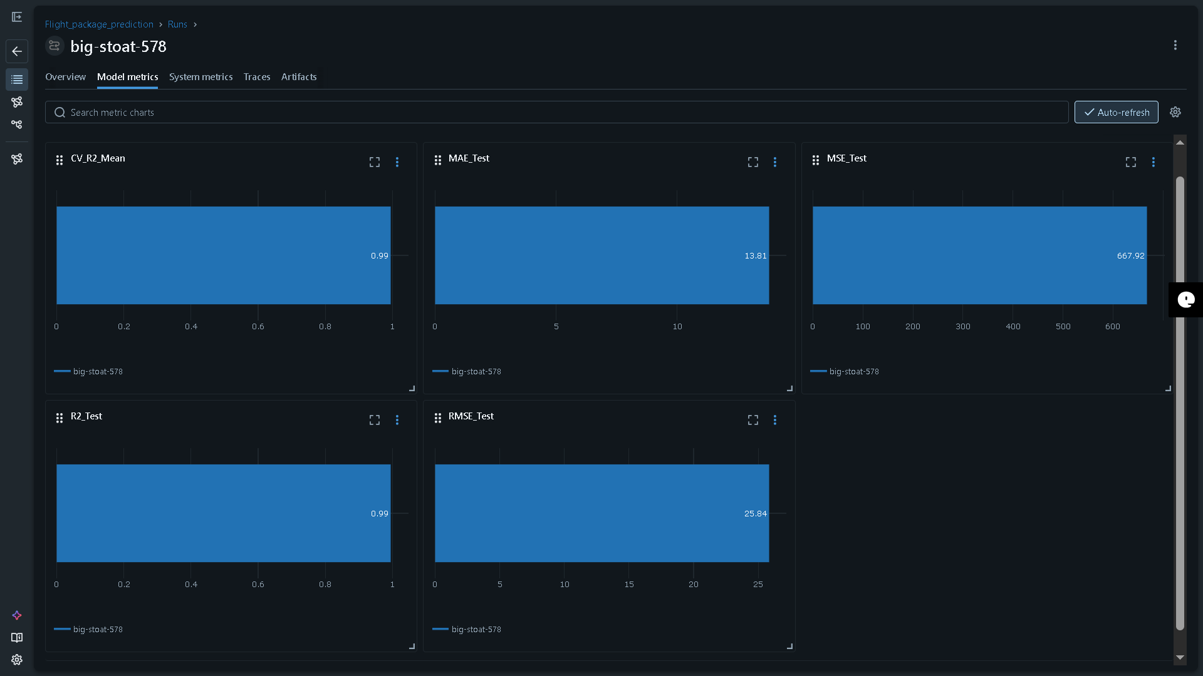

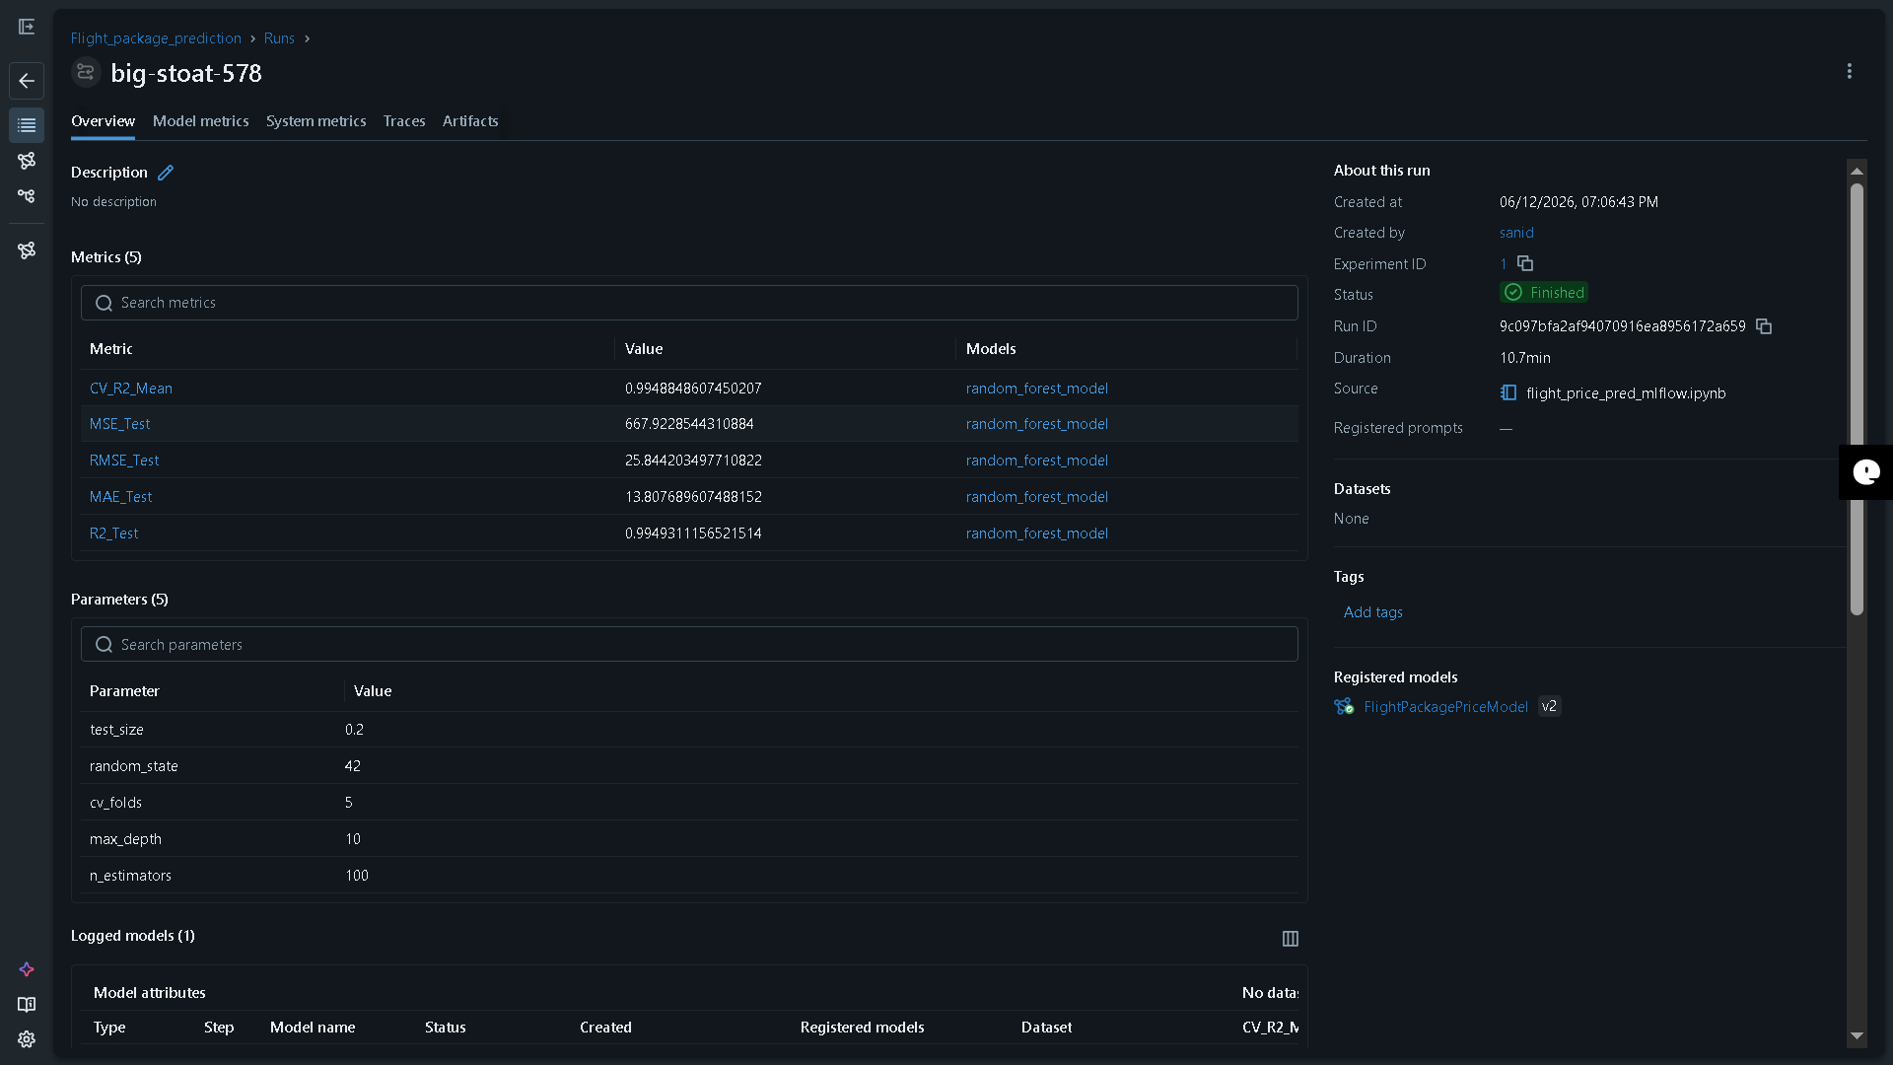

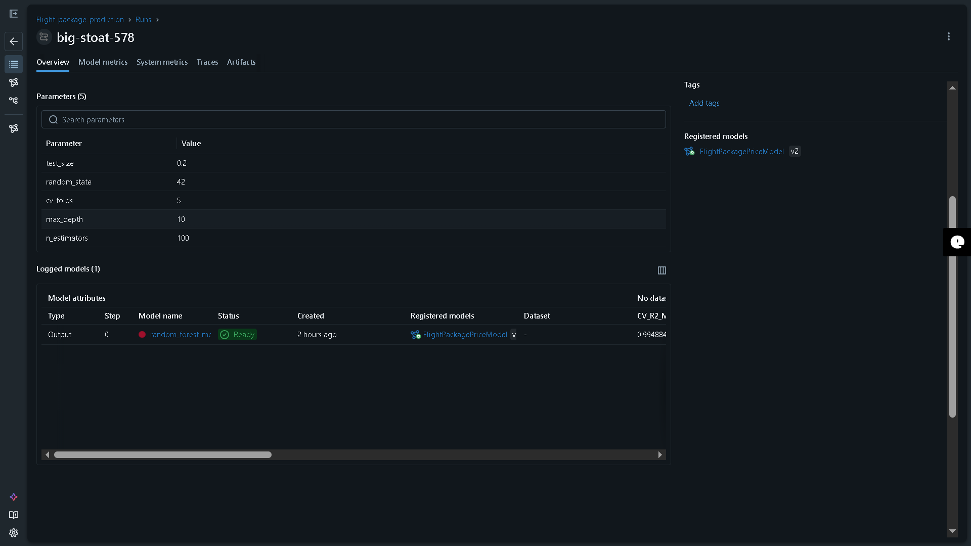

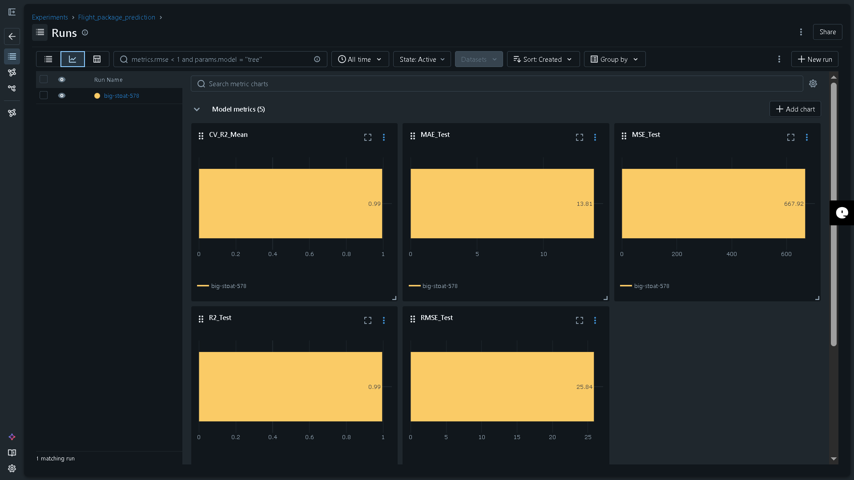

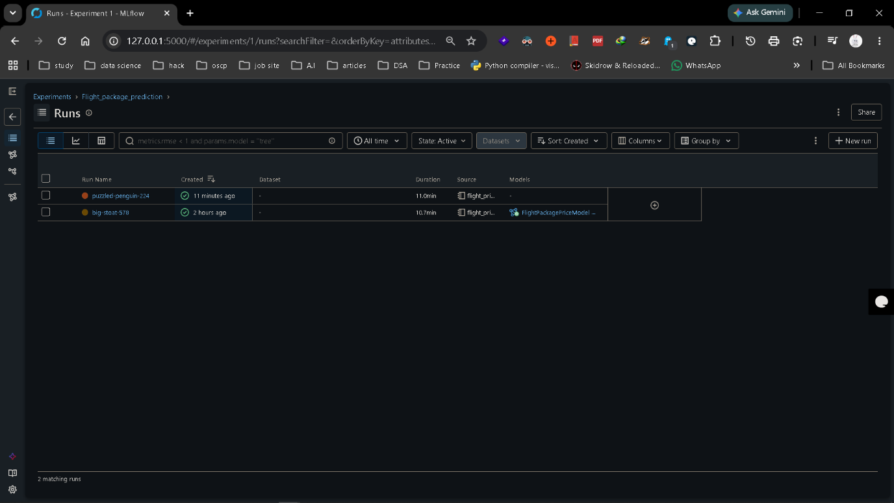
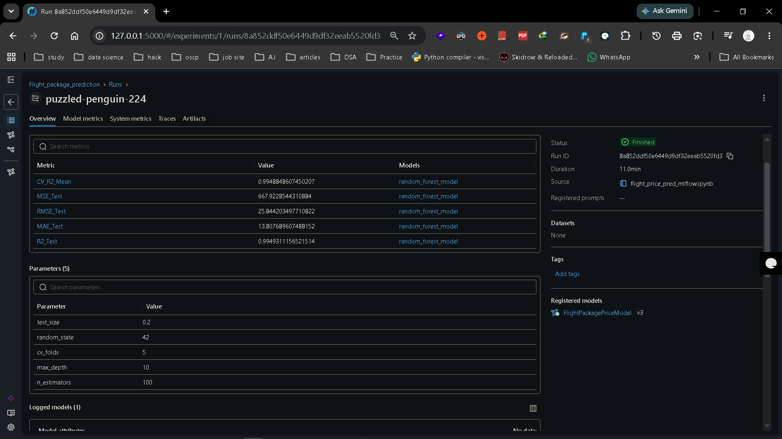

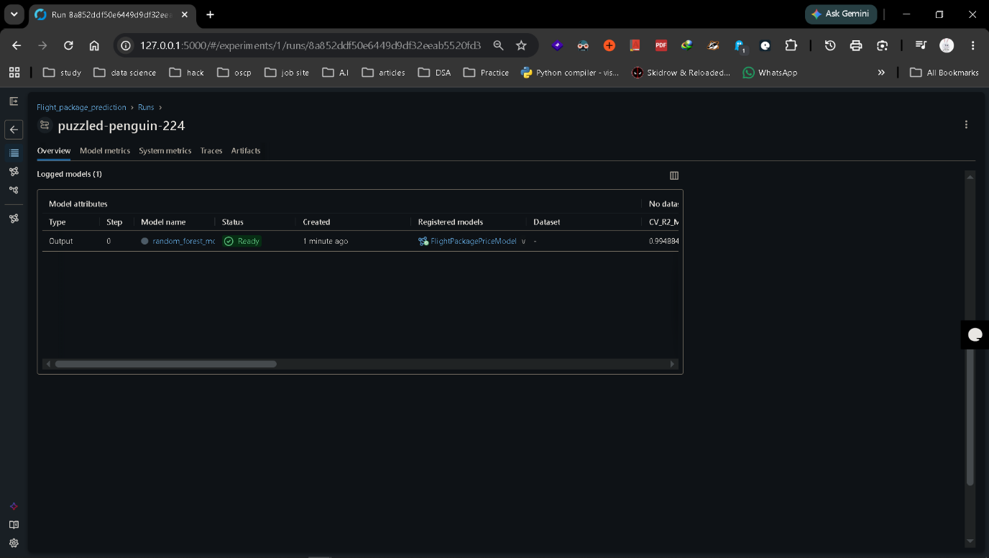

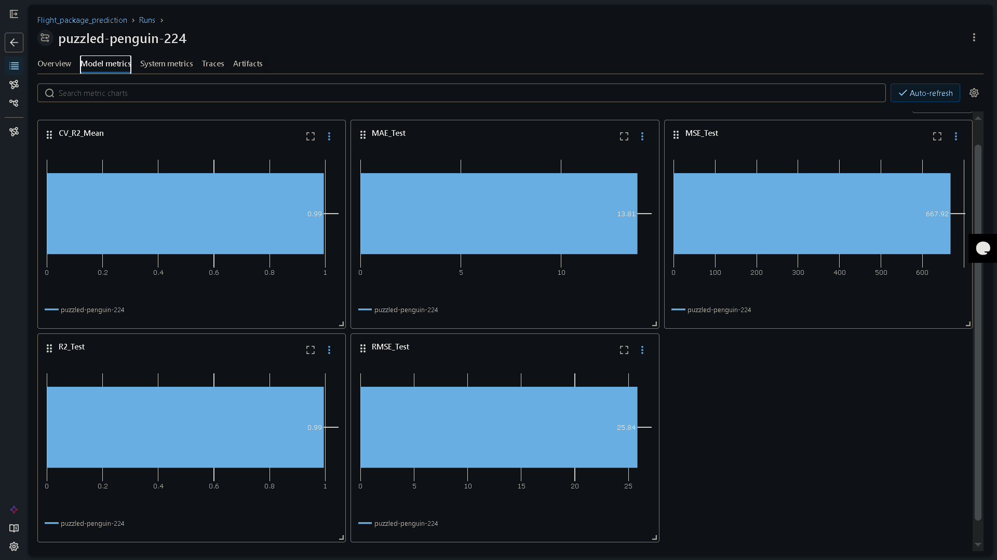

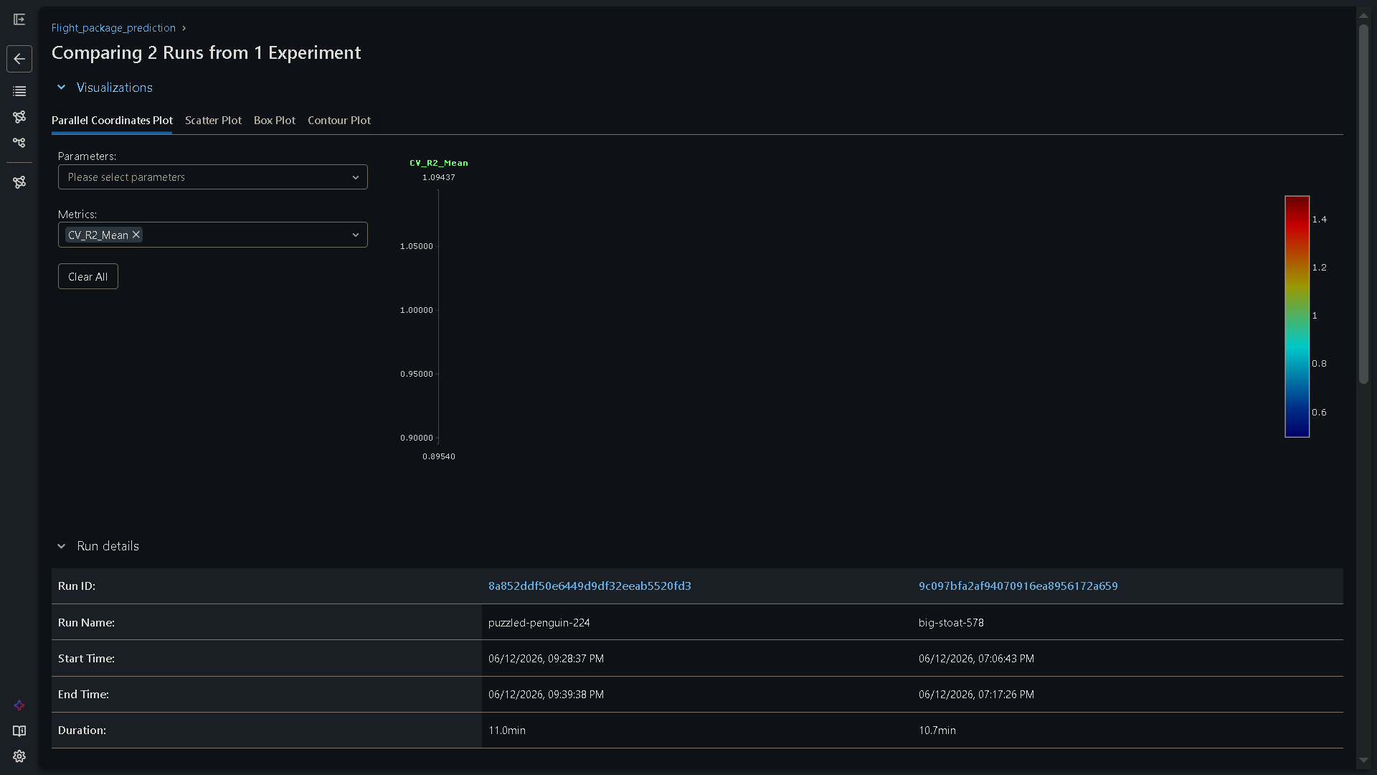

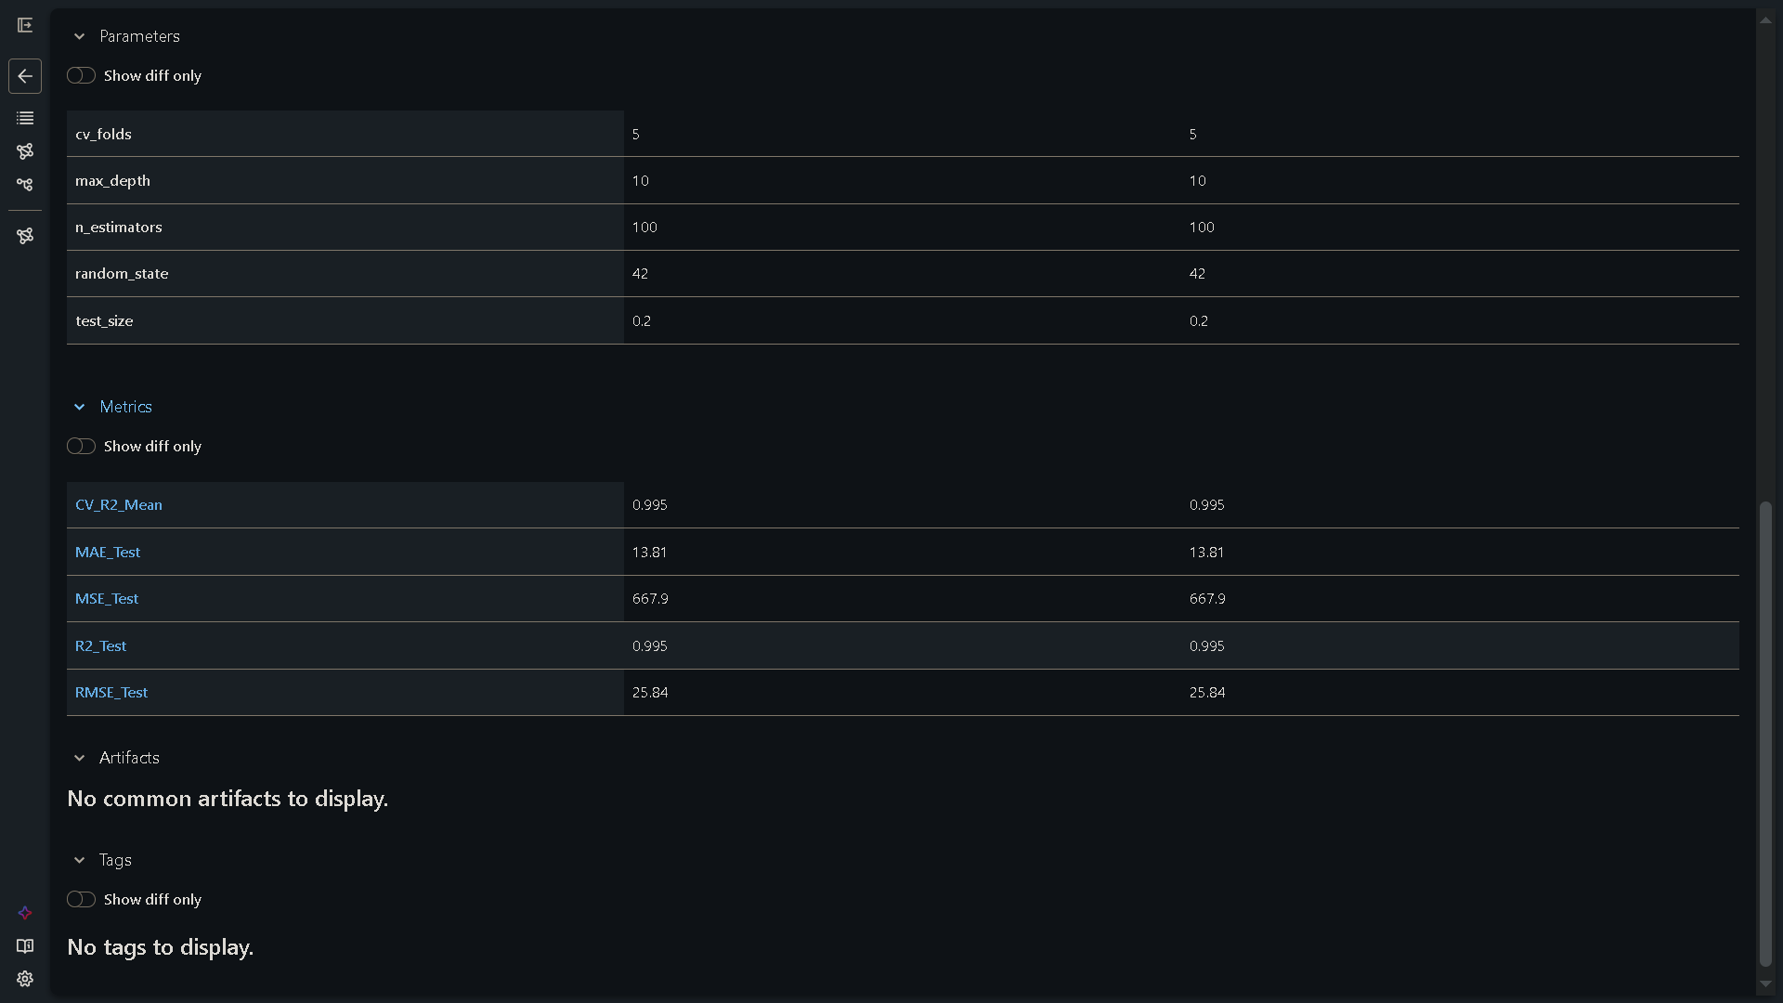

8. GENDER CLASSIFICATION MODEL
- Objective: Deployed a demographic classification framework designed to categorize a user's gender from booking data vectors, helping drive specialized user experience loops and targeted travel marketing layers.
- System View:
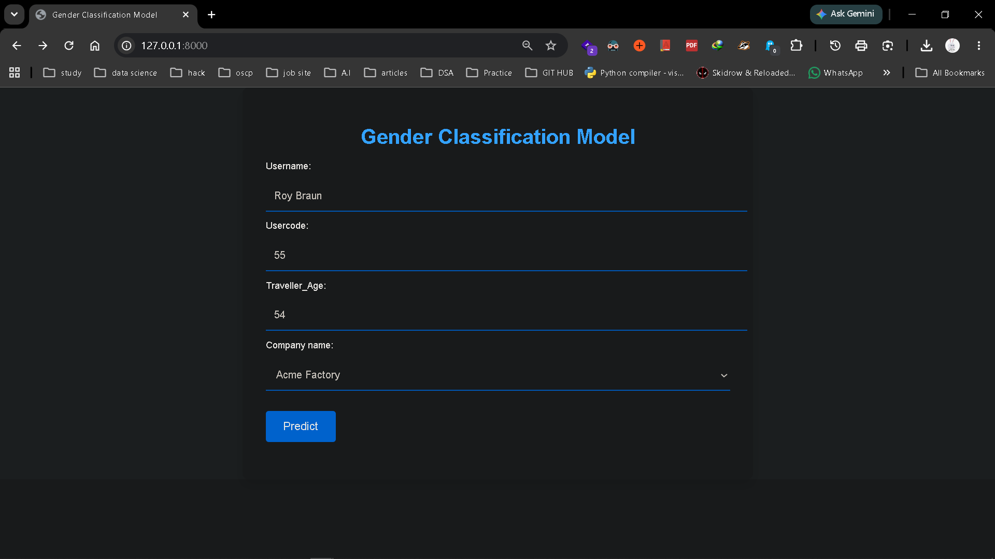
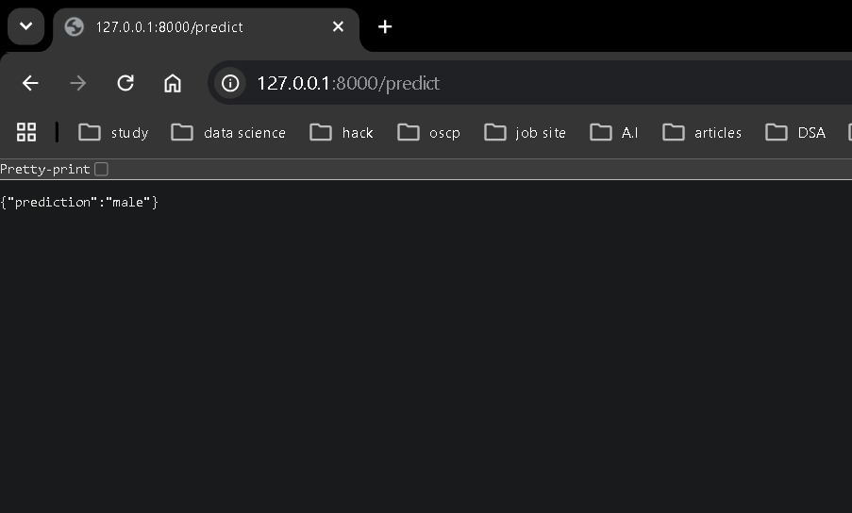
Caption: Functional model validation and layout mapping for the demographic Gender Classification component.
9. TRAVEL RECOMMENDATION MODEL (HOTEL RECOMMENDER STREAMLIT APP)
- Objective: Programmed a custom recommendation system running Matrix Factorization/Collaborative Filtering on historical booking datasets to provide optimized hotel lodging options. Deployed as an interactive Streamlit web application providing clear insights and visualization dashboards.
- System View:
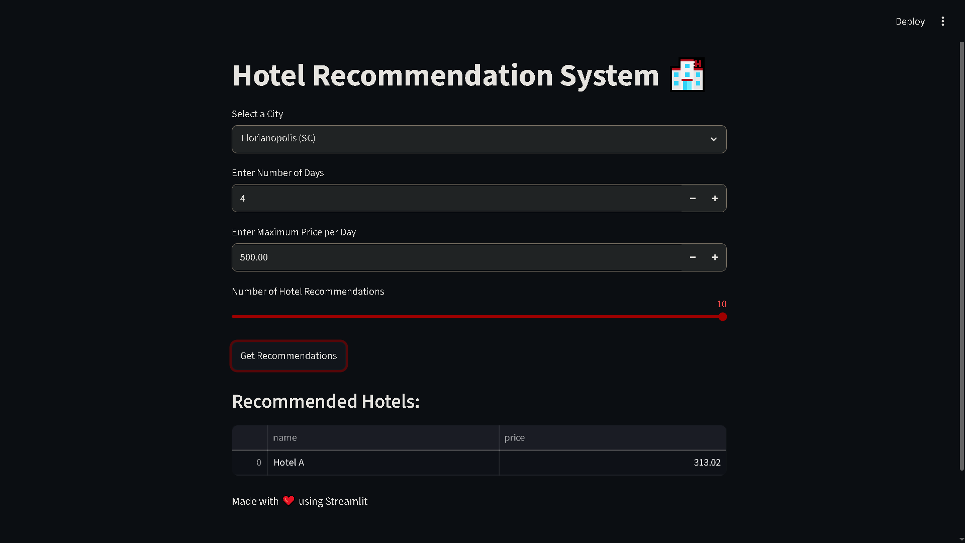
Caption: Live Streamlit web application dashboard displaying personalized hotel suggestions and travel insights.

